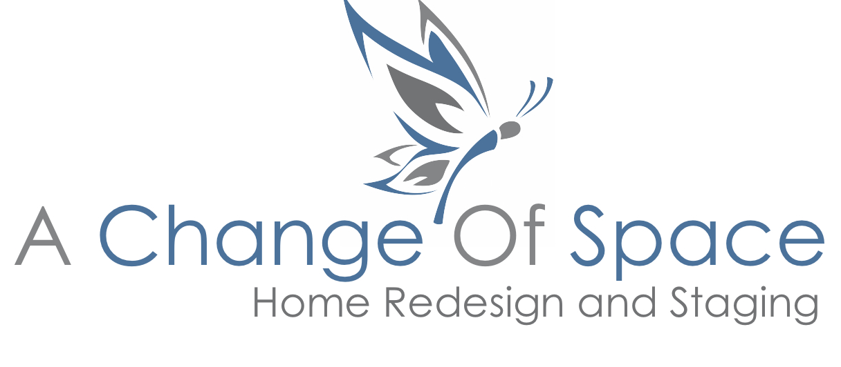
TOP TEN REASONS TO PROFESSIONALLY STAGE YOUR HOME

- You will get top dollar for your home. In a survey of over 3500 homes, professionally staged homes sold for 6% more than their un-staged neighbors.

- Staging cost is small compared to return on investment.

- Your house will sell faster. In a recent Real Estate Staging Association Survey, professionally staged homes spent 72% less time on the market.

- Buyers can more easily visualize themselves living there. In a National Association of Realty Survey, over 81% of buyers said it was easier to visualize the property as their next home.

- On-line photos of beautifully staged homes stand out. According to NAR, over 95% of buyers are online before they call an agent to schedule a viewing.

- It is difficult for a seller to view a home objectively. To merchandise and package effectively, a trained pair of eyes is essential.

- Because purchasing a home is largely an emotional decision, creating a welcoming environment that draws buyers in and makes a lasting impression is key.

- Staging down plays the home’s flaws. Deflect imperfections!

- Most agents consider staging a necessary marketing tool.

- Piece of mind. You will have the satisfaction of knowing you have done everything possible to get top dollar and a quick sale.

Kathy Regini, owner, A Change of Space home staging
www.achangeofspaceco.com
tel.303.818.0828

